Overpopulation and Its impact on the Environment
Name
Institution
Date

Abstract
Our main area on concern on this research paper is the problem of overpopulation as well as its impact on the environment. Over the last decades ago, population growth rates were not an issue thought its origins from the prehistoric time as well as extends the modern world. Over the years, scientists have often acknowledged the concept of overpopulation as well as the anticipated future outcomes on condition that the set precedents carried on based on the same behavioral pattern.
Although, population has continued to increase and people have had constant fights with the diseases such as HIV/Aids, Malaria, cancer among others that reduce it. Moreover, people’s migration has also played a major role in the population increases hence posing great threat to the environment.
Furthermore, urbanization is another factor that has essentially destroyed the natural habitats as well as increased instances of carbon dioxides emissions hence resulting to global warming and climate change in the regions. Human beings’ activities are the primary contributors to the extinction of animal species within the ecosystem. Food security is becoming a major concern because of the issue of overpopulation as more demands for water and food are emanate. Other issues emanating as a result of overpopulation is the inadequate employment opportunities, inadequate education contribute largely in the results of the global inequality.
Overpopulation is the main reason for uneven distribution of natural resources, financial means as well individual rights hence increasing poverty across the globe. It is also identified with the global culture on the greedy as well as aiding of international organizations alongside the agencies.
This paper assists in coming up with solutions to the problem of overpopulation which comprises of the efforts of national institutions in their implementation of policies that correspond to the set guidelines that international institutions such as united nations grant them on the premise that they are the best alternative for global community. This is because individuals at the global networks are believed to work for their best interest while leaving the rest in the extreme poverty issues as well as shortage. The inequalities created frequently support issue often contribute to the overpopulation as well as results to humanity’s extinction.

Table of Contents
Abstract 2
Introduction and Background 5
Figure 1 world population growth rate 6
Research Questions 8
Hypothesis 8
Research Design 8
Methods of data collection 8
Explaining and Measuring the variables 9
Effects of Overpopulation 10
Figure 2: Effect of overpopulation 11
Deforestation 11
Welfare 12
Climate Change 12
Decline in Biocapacity 13
Urban Sprawl 14
Food Security 15
Increase in Energy Demand 15
Limitations of the study 17
Ethical consideration 17
Significance of the proposed research 18

Introduction and Background
Overpopulation refer to the undesirable condition where the number of human beings exceeds the Earth’s carrying capacity. The condition is influenced by factors that include the reduced mortality rates, better medical facilities, depletion of precious resources among other causes. Other factors that contribute to this phenomenon include the increased birth rates, decreased death rates and immigration issues where people are seeking employment in other regions. It is crucial to note a region previously considered as sparsely population might become densely population due to migration of people or when it is unable to sustain the human life. In the modern world it is currently witnessed in developing countries such as India and China.
The growing advances in technology in each year impacts humanity in numerous ways. Medical interventions are one such avenue that seeks to save as well as create a better medical treatment to all the members on the given population. An increase in the lifespan as well as growth of the population. The birth rates and the death rates often balance each other hence maintaining a sustainable population growth rate. There has been a constant population increases reported since the time of Bubonic plague around 1400s. However, in 21st century there were global civil wars, world wars, natural calamities as well as artificial calamities all have resulted to the death among people but only accounts for insignificant figures hence less impact on Earth’s overpopulation.
Developing nations usually face the problem of overpopulation compared to the developed countries. However, the challenges of overpopulation affect most of the Earth as of now. There is need to understand what causes it. As at April 2019, the world population stood at 7.7 billion. Over the last 200, 000 years it experienced a rapid population growth from 1 billion to 7 billion. Previous history illustrated that it took almost the same period of time for population to reach one billion. The rapid growth is a clear indication the world would hit unattainable levels where the natural resources would cater for the entire population.

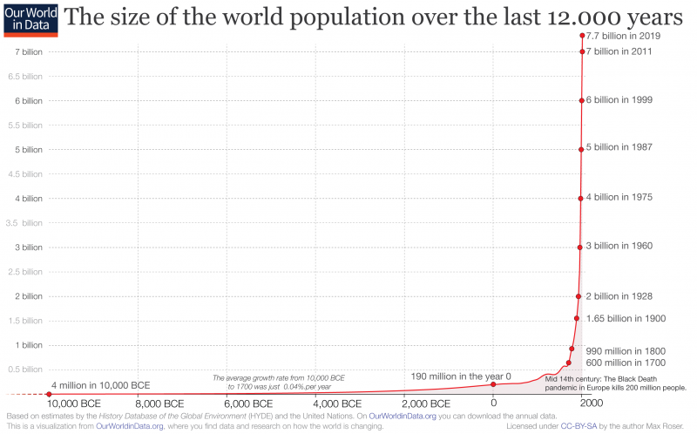

Figure 1 world population growth rate
Source: https://ourworldindata.org/world-population-growth
The statistics also reveal that due to rapid increase in population, close to 1 billion people lack access to safe drinking water. It is also notable that one billion people lack adequate access to minimum dietary requirements. Furthermore, another billion people are chronically malnourished. More than 2.6 billion people globally do not access the basic sanitation and the rest of the Earth is a desert hence its climatic conditions prevent it from human encroachment.
The threat of overpopulation is a major global concern in the modern world. With the population growth expected to attain the 9 billion mark as each year the growth rate is 1.2 percent according to UN statistics. The numbers may not sound alarming but the population internationally is expected to double in less than 50 years. In every second, at least nine births occur into the world which account for at least 140 million people born each year. However, at least every year, there are close to 84 million deaths globally implies that the population growth would grow by 60 million per year. This clearly explains that the world is becoming overpopulated.
The World Trade Center attacks in New York City in 2011 where over 2819 deaths occurred did not have any significant impact on the world population since the number was replaced in a span of 20 minutes. The Environmental activists clearly acknowledge the dangers of the overpopulation. However, the other population explicitly suggest that they would overcome the overpopulation crisis and be able to survive in similar environmental events in the past. They fail to understand the events are quite irreversible as well as activities would not go turn back as it was existed previously.
Moreover, majority of people often concentrate on the short-term goals that only enrich themselves while experiencing pleasure instead of granting full focus on the long-term goals regarding the environmental protection. This suggests why the natural resources globally are diminishing hence every child born is a consideration for the environment to suffer. This expound why human beings must clearly understand that our planet is a bounded system as well as no form of assistance is expected to come from outside. The anticipated scarcity of natural resources would be experienced soon if no efforts for long term goals are undertaken to sort the problems. This paper is geared to create awareness on the impact of the overpopulation on the environment.
Purpose of study
The study is developed as a reference for the policy makers to plan effectively for the population. It is because it contains recent population numbers of people across the globe. Therefore, the United Nations agencies can utilize to find the regions that are population pressures are high and offer assistance. The research acts as an opener for the government in legislating bills and Acts that promote proper housing and settlement for its population.
Scholars and researchers interested in the same line of study can use the information in our research as a foundation for their subsequent researches. It is an important secondary source of information for them to use in planning for their research.

Research Questions
- What are the problems associated with overpopulation?
- Is overpopulation a problem only in the areas that are densely populated?

Hypothesis
- High population density especially in the urban centers does not translate to overpopulation.
- Overpopulation is triggered by numerous factors that presents scenario where the resources are constraint in the regions.

Research Design
The study adopted descriptive survey research design. Descriptive design concentrates on the purpose of the study. The design observes and describes the behavior of the subject under research without influencing its behavior. The data to be used under descriptive design, the objectives are to be clear, valid and reliable on the population of study (Seedhouse, 2005). The design involves an up-close, in-depth, and detailed examination of a subject of study, as well as its related contextual conditions.

Methods of data collection
Collection of data as well as any relevant material for this study was undertaken through desktop research. Secondary data implies to the data obtained from already existing facts as well as researches. Desktop research entailed acquiring information through library search on existing literature and incorporated books, dissertations, population journals, magazines as well as web documents. The collected was based on the how increase in population had an impact on variables such as deforestation, Welfare, Climate Change, Decline in Biocapacity, Urban Sprawl, Food Security and Effect on Marine Ecosystem

Explaining and Measuring the variables
The world has a duty to understand the damaging impact created by rapid increase in world population. Deforestation is defined as the clearing, destroying as well as deliberate, intentional or accidental removal of trees especially in the densely populated by trees alongside other plant life for instance in Amazon. Welfare implies to the quality of people’s life and is determined by the individual’s financial status, education, social life, family life, health as well as employment opportunities. Biocapacity decline which implies that continued increase on the population globally would have increased pressures on the natural resources to levels never thought before. The urban Sprawl implies to the rapid migration of people into the urban region hence creating development of real estates, producing low density, scattered and discontinuous car dependent construction usually on the periphery of declining older suburbs as well as shrinking of urban cities. The increased population has contributed to food insecurity as people are not producing enough food to cater for the increased population and lastly impact on the marine ecosystem where fishing and other marine activities has continued to impact on the marine life such as fish.
Discussions of Results and Findings
The world population consists if of over 7.3 billion as at statistics reported in 2015 and is expected to attain a growth of 9 -12 billion before the year 2050. This illustrates that the world would be in great danger of overpopulation by 2050 (Nagar 2017). It is expected to contributed to the ecological changes as well as impose the burden on the biodiversity. The least developed countries population growth is 2.3 percent per annum while the developing nations its growth is 1.2 percent as per 2000 United Nations statistics (Davis, Arnocky, and Stroink, 2019).
Human population rapid rise in population contributes to the risk of synergies among the effects that resulted to the accelerated environmental degradation. It has resulted to the adverse environmental health especially in the agricultural activities and technological development across the globe. The adverse effects of an agriculture or even the technological society on the abiotic as well as biotic components of the environment are usually expounded on the simplest terminologies. The rapid human population growth rate in the last centuries ago has greatly resulted to the encroached the wildlife habitats and eminent destruction hence posing a great danger to the biodiversity components (Clark, 2016).
Modern agricultural activities and practices, modern medical facilities as well as illiteracy in the rural areas is the major reason for demographic transition hence more natality rates and decline in mortality rates. The academy to panel statement on population growth illustrate that numerous environmental concerns including increased levels of greenhouse gases, biodiversity threats, environmental pollution and climate change. There is need to come up with policy frameworks and develop new perspectives while developing some recommendation to combat the adverse impact of the overpopulation

Effects of Overpopulation
The study reveals that overpopulation despite contributing to the nation’s economy at global reach, it is associated with adverse environmental implications. The figure 2 illustrates some of the adverse effects of overpopulation.
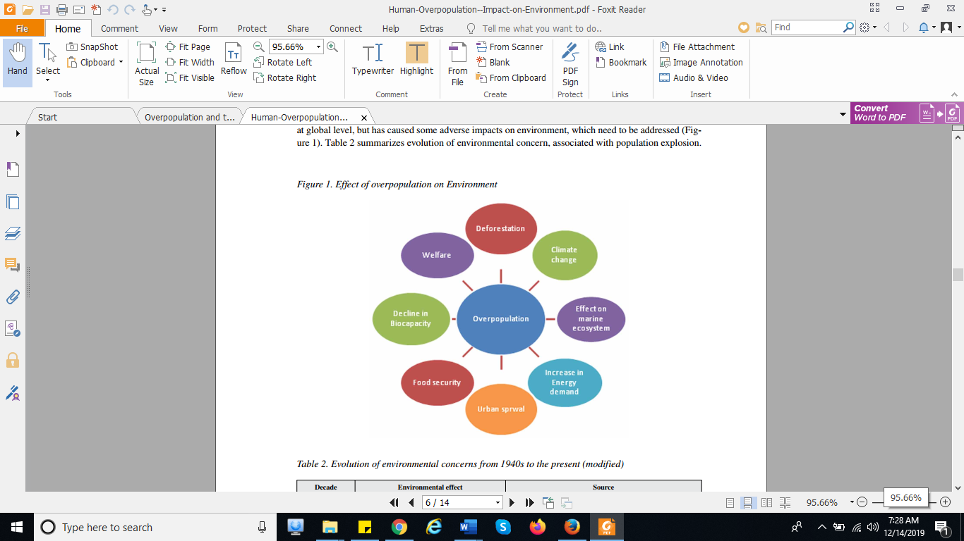

Figure 2: Effect of overpopulation

Deforestation
The study reveals that increased urbanization contributes to the rapid deforestation rates globally. It is because demand to fulfill the infrastructure demands owing to the increasing population. The regions with canopy trees are usually subjected to deforestation. Moreover, continued migration of people to urban regions from rural areas clearly depict the need for more deforestation activities.
The 2015 report on world migration revealed that the net migration from rural migration had increased to close to 9 million each year. For instance, in 1981–1991 was 11 million while in 2001-2011 to 19 million in India alone (Nagar 2017). The population growth has created jitters and led to exponential increase in the alternation of the land utilization patterns. This is to supplement economic needs obtained from the agricultural products, timber as well as the fuel woods. The conversation of the forest area to agricultural, industrial and residential due to increased population. This explains the need to bodies and laws to conserve the environment such as the Forest Conservation Act enacted in 1980 in India. This had a reprieve as it hindered people from converting forest land for humans’ activities and practices (Nagar 2017).

Welfare
The quality of life for people is greatly influenced by the overpopulation. People’s quality of life is employed to determine their satisfaction levels. Some of the aspects considered in this case is the individual’s financial status, family life, employment, education, health and social status. Increased population has a major impact on the existing resources as all people demand them hence resulting to increased poverty levels. For instance, India is among the nations with highest population globally experienced drastic increase in poverty levels from 27.09 % to 41.79 % in the year 2005 (Nagar 2017). This was attributed to the population unable to acquire education among the mass poor people in the population.
Furthermore, increased illiteracy levels contributed to the more increase in population due rapid rise in fertility rates. The poor people do not have adequate information about the environmental degradation as a result of their mass increase in population. The literate women exabits low fertility rates when a comparison with illiterate women was undertaken in all states of India. However, some states had a slower value of general fertility rates for illiterate population compared to the literate population. It is also explained by the fact, some states with high population like India do not effectively manage and control the medical facility.

Climate Change
There are recent reports on the climate change illustrated that some frequency as well as catastrophe in the extreme weather conditions that results to the costly damage of infrastructure and loss of human life. Moreover, increase usage of the fossil fuels in the overpopulate regions across the globe hence resulting to increased release of carbon dioxide into the atmosphere. Increased overpopulation also accelerates agricultural practices that results in emission of the greenhouse gases. For instance, methane gas is manufactured from agricultural practices such as crop farming mainly rice as well as livestock farming. 24 % of the 2010 global emissions in carbon emissions resulted from agriculture sources (Nagar 2017). Reduction of the population especially in the high-income countries is the remedy to the emissions. Therefore, any instances on the population growth rate reductions especially in high income countries irrespective of any decline has a huge impact ability to reduce climate change. This is in comparison with similar size in a more lower income countries which has a lower per capita hence less consumption as well as emission of greenhouse gases. The higher income countries are able to switch to alternative sources energy including tidal, wind and solar energy unlike in lower income countries. The general fertility rates compared to the education levels of women in India as well as bigger states offered improvements in the agricultural practices that assist in combating the problems of climate change due to increased population.

Decline in Biocapacity
There is a general decline in the resource consumption as a result of the rise in global population. This has resulted to additional pressure on the existing natural resources to unimagined levels. Biocapacity is defined as the region constituting productive land and water to create resources as well as absorb carbon dioxide waste under the present management practices.
The increased pressure on the ecological resources results to a decline in biocapacity. This is because the existing resources are unable to support consumption as they require wide population. A comparison of 1961 and 2008 statistics reveal as sharp decline per head from 3.2 global hectares to 1.8 global hectares per capita respectively despite the global increase in biocapacity in the same period. The ecological foot print illustrates that the land area is requires to meet the consumption as well as the waste absorption needs of a given population. Moreover, it is applied in examining the availability as well as the utilization of the ecological resources which should assist in the sustainable utilization of resources.
There is an increased demand for the renewable resources from 7.6 billion global hectares to 18.1 global hectares in 1961 and 2010 respectively. This is due to the increased population clearly depicting that unsustainable status might be attained in the near future.

Urban Sprawl
Urban sprawl implies to the mass migration of people from populated towns as well as cities to low density residential development over more as well as moral rural land. This results in the spreading of the city as well as its suburbs across a more and more rural land. This is because real estate’s sprung up the sparsely populated regions. It also results to the scattered and declining existing suburbs while at the same time shrinking the city centers.
The global urban population is expected to grow to at least 4.9 billion by the end of 2030 while decreasing the rural population by at least 28 million from 2005 to 2030 (Nagar 2017). The urban growth in the United States is anticipated to utilize close to 19 Million acres of farmland between 2000 and 2025 which is sensitive to environmental as well as other lands. The natality rate and increased immigration is the major contributor to the urban sprawl.
The migration of population from the rural areas to urban regions is precipitated by the better living facilities alongside the desire for employment opportunity. In most cases, the government are unable to offer all basic services as well as improve the quality of life to people living in the huge urban regions. Therefore, massive sprawl urban effect takes the center stage which may have an adverse environmental degradation.

Food Security
The increased overpopulation issues have contributed to the worsened the local as well as global food security through synergistic effects of the climate change. There is climate change that emanate from emission of greenhouse gases hence posing a major threat on food security which impacts on the agricultural crop productions and biodiversity.
The food security is often associated with food availability, accessibility as well as consumption. An increase in urbanization contributes to the limited growth of the agricultural sectors which contributes to industrial development in the rural areas. The present production levels of food are not adequate to cater for the increased population growth. This is because crop production largely depends on presence of natural resources including water, energy as well as land resources. For example, to produce 1kcal of food production, an individual must utilize close to 10kcal of energy. The fossils energy is limited in the amounts hence depicting that humans are only able to produce only a fraction of the food produced for the entire population. Moreover, it only 50 % of the world’s land that can allow agricultural activities through the irrigation. Other aspects are the fact that land is affected by soil erosion, salination, acidification at the same time may experience nutrient depletion hence affecting the crop growth rates and production levels. Consequently, it results to food security for the increasing population growth rates hence becoming a threat to survival of the population (Kaushik, et al., 2017).

Increase in Energy Demand
The energy demand tends to increase with the continued increase in the overpopulation across the globe. Consequently, issues of rapid inflation in the energy requirement coupled with subsequent utilization are witnessed. The use of the energy particularly the fossil fuels has drastically risen over the last three decades to nearly 85 % while higher rates are experienced in Asia with over 300 %. To sustain the demand for the energy sources there is increased to apply the renewable resources. Moreover, energy conserving devices particularly in the household’s energy consumption can be utilized. There is also need to craft and implement technologies that are geared for energy generations such as a biological source. The biogas plants that that utilize the animal wastes can be utilize to produce energy that can subsequently be used in the households.
Effect on Marine Ecosystem
Increased levels of population have a huge impact on the marine life especially on the coastlines. Migration activities such as tourism, fisheries and commercial beaches as well as mangroves along the coastal areas have damaged the utilization practices and cause adverse environmental degradation in the region. The coral reefs are often degraded as a result of direct effect of the climate change as well as well human activities that lead to marine pollution and overfishing activities. For instance, close to 45 % of the 19210 km² of coral reefs in the South Asia are no more. 10% of them are critically threated, 15 % are threatened while another 20 % are at low risk. Another example is the Mesoamerican Barrier Reef whose coral cover that is attributed to at least 11 % of decline since 2004 and more than 50 % cover loss on the some of its reef (Nagar 2017).

There is need for international agencies to craft agreements to sort the issue of marine biodiversity because the increased population levels would have significant effect on the marine biodiversity. Policies need to be created to curb human activities that are threat to the marine existence in the biodiversity.
Positive Effects of Overpopulation
The scientists suggest that in the long run, overpopulation may attain levels where the earth might not be able to sustain life. However, the explained that there are some benefits that occur as a result of increasing population across the globe. These benefits include; the rise in the human resources and production of relatively cheaper and innovative as well as readily available commodities (Singh et al., 2016). Other benefits are the economic benefits and increased demand for products from industries. The increased number of people especially the youths is a reprieve for the developmental activities. Such nations are likely to experience boost in the economic growth of the country on scenario where the demand for improved services increases. There is need for the government in such region to develop well informed policies so as to benefit from the growing population in the country. The countries are also in position to employ the available human resources effectively hence improving the health care, medicine and increase food production for the growing population.

Limitations of the study
The study is limited because the number of deaths and births in a population differ from one region to another depending on health conditions. Furthermore, natural calamities and artificial human activities such as bombing impact the population negatively. The study was also faced with limitations in getting sufficient data. Some of the data was collected from third parties thus it may not be accurate. Hence, researcher’s biasness would affect the quality of the study hence the policies being made (Carter, 2018).

Ethical consideration
People across the globe must clearly understand that natural resources are limited but are very vital for the human race. Therefore, the resources ought to be valued as well as preservation and conservation must be ultimate goal of everyone. It is because the resources are the source of food among other essential resources that people consume on daily basis (Judge, 2018).

Significance of the proposed research
There is need to evaluate the population structure of the various nations while unleashing the factors that contribute the demographic pyramid in the given country. There is need to carry out research to determine ways through which states could maintain impartial resource’s sharing. This is to prevent the carrying capacity of the ecosystem from increasing. This would facilitate effective ways through which programs such as family planning are adopted to reduce on the population growth rate.
Conclusion and Recommendations
There are numerous effects of overpopulation across the globe. This because as the population increases the natural resources are depleted though human activities. Encroachment of wildlife areas occurs resulting to issues unbalanced ecosystem. Tress and forests are cleared to pave way for industrialization activities across the globe which would increase global warming issues hence resulting to climate change. There is need for international agreements that restrict the extend through which human beings utilize the natural resources (Baus, 2017).
Overpopulation effects the food security which can be sorted out through increasing food production, economic accessibility to food and bettering food distribution channels. The deforestation issue may be improved through crafting and implementing programs and policies that hinder people from clearing forests and trees. Moreover, the is need to create awareness on the need to use the renewable sources of energy. There is need to reduce urban sprawl since it results to clearing of the forests and trees in the rural areas for settlement. Some cities such as India should develop a policy of one child per family to control the increased levels of migration in the country.

References
Baus, D. (2017). Overpopulation and the Impact on the Environment.
Carter, E. D. (2018). Overpopulation. In Companion to Environmental Studies (Vol. 76, No. 80, pp. 76-80). ROUTLEDGE in association with GSE Research.
Clark, T. (2016). ‘But the real problem is….’: The Chameleonic Insidiousness of ‘Overpopulation’in the Environmental Humanities. Oxford Literary Review, 38(1), 7-26.
Davis, A. C., Arnocky, S., & Stroink, M. (2019). The Problem of Overpopulation: Proenvironmental Concerns and Behavior Predict Reproductive Attitudes. Ecopsychology, 11(2), 92-100.
Judge, A. (2018). Prohibition of Reference to Overcrowding.
Kaushik, G., Patil, S. S., Singhal, P., & Chel, A. L. (2017). Overpopulation and Its Association with Natural Disasters: A Case Study of Indian Tsunami, 2004. In Environmental Issues Surrounding Human Overpopulation (pp. 189-201). IGI Global.
Nagar, P. (2017). Statistical analysis of socio-economic and cultural determinants affecting population growth in Rajasthan. Journal of Progressive Agriculture, 8(2), 146-151.
Singh, R., Srivastava, P., Singh, P., Upadhyay, S., & Raghubanshi, A. S. (2016). Human Overpopulation and Food Security: Challenges for the Agriculture. Environmental Issues Surrounding Human Overpopulation, 12, 13.

